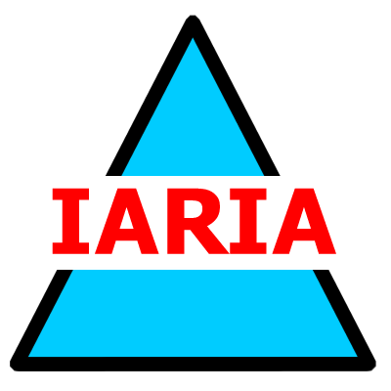  www.iaria.org | International Conference on Advances in Human-oriented and Personalized Mechanisms, Technologies, and Services  I-CENTRIC 2008  October 26-31, 2008 - Sliema, Malta  http://www.iaria.org/conferences2008/I-CENTRIC08.html

Important deadlines:
Full paper submission May 10, 2008
Authors notification June 20, 2008
Registration and camera ready July 20, 2008

Topics:

I-centric mechanisms  - Machine learning and artificial neural networks  - Network control and feedback with man-in-the-loop  - Personalized storage and information retrieval with user-context  - Service discovery using user profile  - Personalized navigation and visualization  - Semantic web services  - Advanced personalization techniques for semantic wikis  - Application of advanced reason maintenance and reasoning to user modeling and personalization  - Combining results of information extraction and semantic web technologies with personalization and user modeling  - Quality of experience  Technologies for personalized services  - Body networks  - On-body antennas  - Contactless radio: RFID, NFC  - Proximity radio: Bluetooth, WLAN  - Broadband and wireless broadband distribution  - Ambient, wireless and broadband networks  - Emergency and medical response systems  - Proximity and context-aware services  - Personal entertainment  - IPTV and Quadruple Play | I-centric networking and services  - Personal profiles, preferences  - Identity  - Social communities  - User adapted services  - Trust, privacy, security  - Community services  - Location services  - Web 2.0 and Web 3.0  - Key exchange, certificate handling, smartcards  - Personal devices  - Managing identity and security - identity provider  - Home content access and rights management  I-centric advanced applications  - Humanoids  - Body networks and devices  - Preventive and personalized medicine  - Unmanned systems  - Anticipative systems for diagnosis and maintenance  - Social engineering and social networks

